**RAID and its types**

**RAID** (Redundant Array of Independent Disks) is a data storage technology that combines multiple physical disk drives into a single logical unit to achieve redundancy, improve performance, or both. Initially, RAID stood for "Redundant Array of Inexpensive Disks," reflecting its use of cost-effective drives to enhance performance and reliability. Today, it is commonly referred to as "Redundant Array of Independent Disks" to emphasize the independence of the drives.

RAID systems are extensively used in servers, workstations, and storage systems to enhance data reliability and access speed. By distributing data across multiple disks, RAID can provide various levels of redundancy and performance improvements, depending on the configuration.

Different RAID levels offer varying balances between performance, data redundancy, and storage capacity. Each level is designed to address specific needs, such as high-speed data access, fault tolerance, or a combination of both. Understanding the nuances of each RAID level is crucial for selecting the right configuration for a given application, ensuring optimal performance and data protection.

**RAID 0 (Striping)**

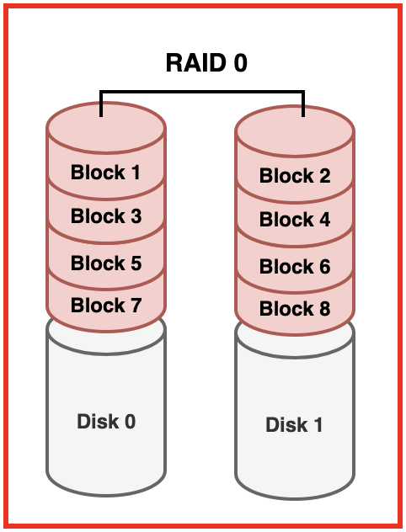

RAID 0 uses a technique known as striping, where data is divided into blocks and each block is written to a separate disk drive. This method significantly enhances data throughput and improves performance because read and write operations are spread across multiple disks, allowing for parallel access. The striping process effectively multiplies the available bandwidth, making RAID 0 suitable for applications that require high data transfer rates, such as video editing and gaming.

However, RAID 0 lacks redundancy, which is a significant drawback. If one disk in the array fails, all data stored across the disks is lost, making RAID 0 unsuitable for critical data storage. Despite its performance benefits, the absence of fault tolerance means that RAID 0 should only be used for non-critical applications where speed is the primary concern and data loss can be tolerated.

**RAID 1 (Mirroring)**

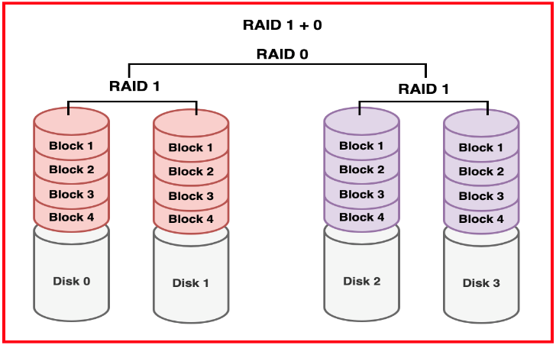

RAID 1, or mirroring, involves writing identical copies of data to two or more disks. This setup ensures data redundancy, as each disk contains an exact copy of the data. The primary advantage of RAID 1 is its fault tolerance; if one disk fails, the system can still function using the mirrored copy on the other disk. This high level of data protection makes RAID 1 ideal for storing critical data that must be readily available at all times, such as databases and financial records.

In terms of performance, RAID 1 offers improved read performance since data can be read from any of the mirrored disks. However, write performance remains similar to that of a single disk, as data must be written to all mirrored disks simultaneously. The major trade-off with RAID 1 is storage efficiency, as it effectively reduces usable capacity by half due to data duplication. Despite this, the enhanced data reliability and fault tolerance make RAID 1 a preferred choice for many critical applications.

**RAID 5 (Striping with Parity)**

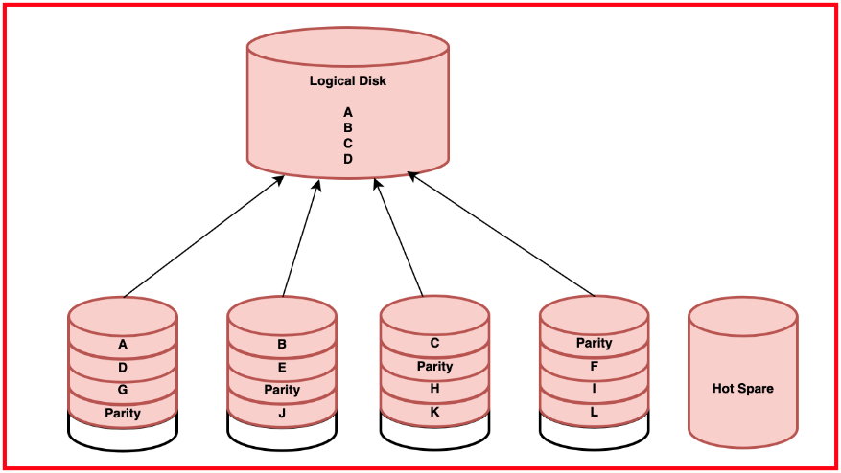

RAID 5 combines striping with distributed parity, offering a balance between performance and fault tolerance. Data and parity information are striped across multiple disks, with the parity information allowing the system to reconstruct data in the event of a single disk failure. This configuration provides good read performance due to parallel access to data blocks, although write performance is slower compared to RAID 0 due to the overhead of parity calculations.

RAID 5 is storage-efficient, providing the total capacity of (N-1) disks, where N is the number of disks in the array. This makes RAID 5 a popular choice for environments that require a balance of good performance, data protection, and efficient use of storage space. Common use cases for RAID 5 include file servers and backup solutions, where the ability to tolerate a single disk failure without data loss is critical.

**RAID 10 (Striping and Mirroring)**

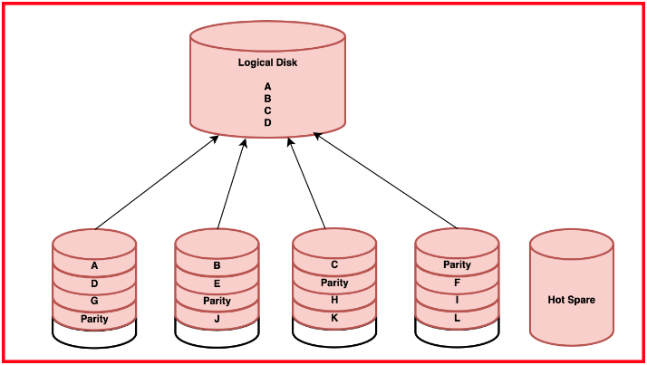

RAID 10, also known as RAID 1+0, combines the benefits of both RAID 0 and RAID 1 by using both striping and mirroring techniques. Data is striped across multiple disks for high performance and then mirrored for redundancy. This configuration provides high read and write performance due to the striping, while the mirroring ensures data redundancy and fault tolerance.

Although RAID 10 reduces usable storage capacity by half due to mirroring, it offers the best of both worlds: high performance and high reliability. RAID 10 can sustain multiple disk failures as long as no complete mirror pair fails, making it ideal for applications requiring both high performance and high availability. Typical use cases for RAID 10 include transactional databases, high-performance computing, and any mission-critical applications where downtime is not an option.

**RAID Performance, Fault Tolerance, and Use Cases**

The performance and fault tolerance of RAID levels vary significantly, making it essential to choose the right configuration based on specific needs. RAID 0 offers the highest read/write performance due to striping but lacks fault tolerance, making it suitable only for non-critical applications. RAID 1 provides good read performance and excellent fault tolerance through mirroring, ideal for critical data storage.

RAID 5 strikes a balance between performance and fault tolerance by using striping with distributed parity, suitable for environments needing efficient storage and reliability. RAID 10, with its combination of striping and mirroring, offers high performance and redundancy, making it perfect for high-demand, mission-critical applications. Each RAID level has its unique strengths and trade-offs, and understanding these is crucial for selecting the appropriate RAID configuration to meet the specific requirements of different applications

**Security threats and vulnerabilities**

I/O system security is very important for keeping data safe. It protects the pathways that connect a computer to external devices. These pathways can be vulnerable to many attacks that can affect the **integrity**, **confidentiality**, and **availability** of data.

**Data Interception**

Data interception happens when unauthorized people access data while it is being sent between devices. This can lead to:

* Data breaches
* Loss of sensitive information
* Unauthorized disclosure of confidential data

To prevent these risks, encryption methods like SSL/TLS can be used. This means that even if data is intercepted, it cannot be read without the right decryption keys.

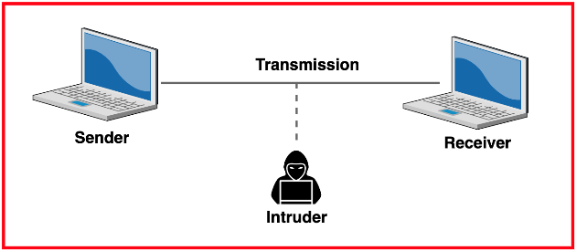

**Man-in-the-Middle (MitM) Attacks**

In a Man-in-the-Middle attack, an attacker secretly intercepts and possibly alters communication between two parties. This can compromise data. For example:

* The attacker can listen to conversations (eavesdropping).
* They can inject harmful data into the communication.
* They can change the content being sent.

To prevent MitM attacks, strong authentication and encryption should be used.

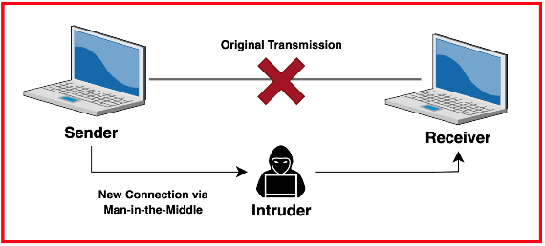

**Hardware Tampering**

Hardware tampering involves physically changing or compromising I/O devices. For example:

* Adding a rogue device that records keystrokes.
* Modifying firmware to change how a device works.
* Installing hardware to access data without permission.

To protect against this, organizations should:

* Use strong physical security measures.
* Conduct regular checks on hardware.
* Use tamper-evident seals to spot unauthorized changes.

**Denial of Service (DoS) Attacks**

Denial of Service attacks aim to make I/O systems unusable. These attacks can overwhelm a system with too many requests, causing it to:

* Slow down
* Crash

To mitigate DoS attacks, robust network security measures, such as firewalls and intrusion detection systems, should be implemented.

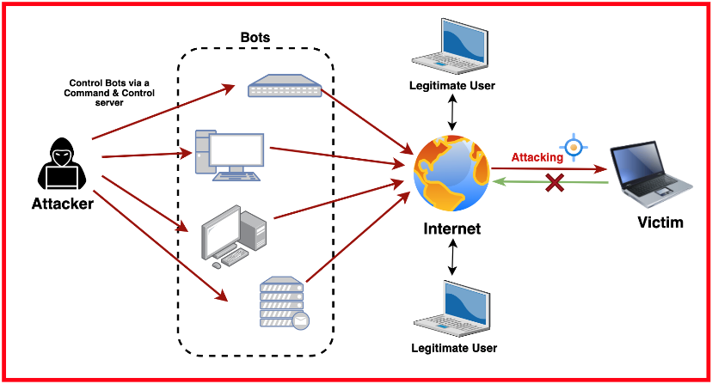

**Buffer Overflows**

A buffer overflow occurs when a program writes more data to a buffer than it can hold. This can lead to:

* Unexpected behavior in the system
* Executing harmful code
* Unauthorized access to the system

To prevent buffer overflows, developers should:

* Use secure coding practices.
* Use automated tools to find potential issues.
* Thoroughly test software components